Ray in a Plane
# Source: AI Source: Provided by: [Data Path: Persons Table -> ID Column: 1, Name_En Column: Motasem Essam] -> From: [ChatGPT] on [7/25/2026]
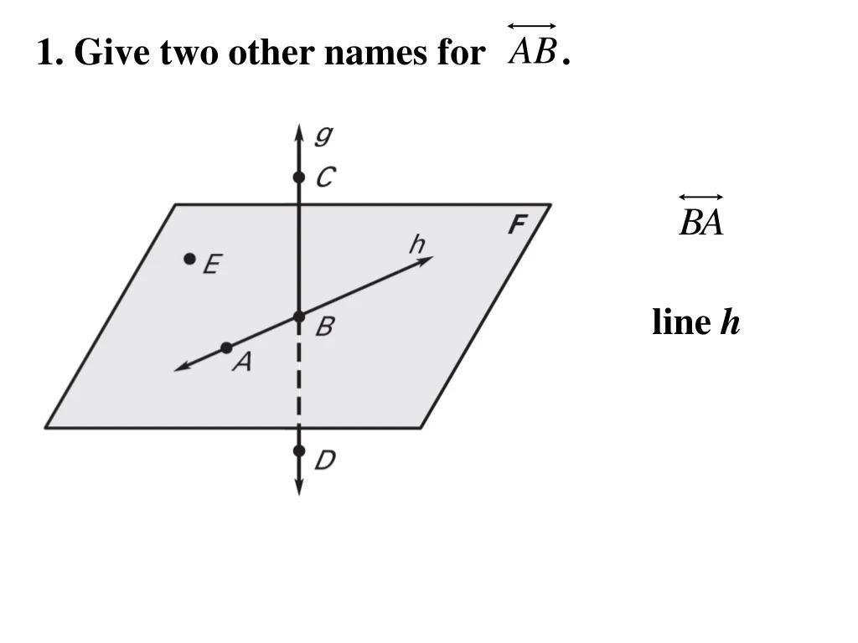

Definition
# Source: AI Source: Provided by: [Data Path: Persons Table -> ID Column: 1, Name_En Column: Motasem Essam] -> From: [ChatGPT] on [7/25/2026]
A ray in a plane is a part of a straight line that begins at a fixed point, called the endpoint, and extends infinitely in one direction while remaining entirely within a particular plane.
In solid geometry, a plane is a flat two-dimensional surface that extends infinitely in all directions. A ray can lie completely within that plane, even when the plane is considered as part of three-dimensional space.
If $A$ is the endpoint and $B$ is another point on the ray, the ray is written as:
$$\boxed{\overset{→}{AB}}$$
The ray begins at $A$, passes through $B$, and continues indefinitely beyond $B$, without leaving the plane.

Simple definition
# Source: AI Source: Provided by: [Data Path: Persons Table -> ID Column: 1, Name_En Column: Motasem Essam] -> From: [ChatGPT] on [7/25/2026]
A ray in a plane is a straight path that starts at one point and extends forever in one direction, staying on the same flat plane.
The ray starts at A and continues through B, remaining within the plane.

Key characteristics
# Source: AI Source: Provided by: [Data Path: Persons Table -> ID Column: 1, Name_En Column: Motasem Essam] -> From: [ChatGPT] on [7/25/2026]
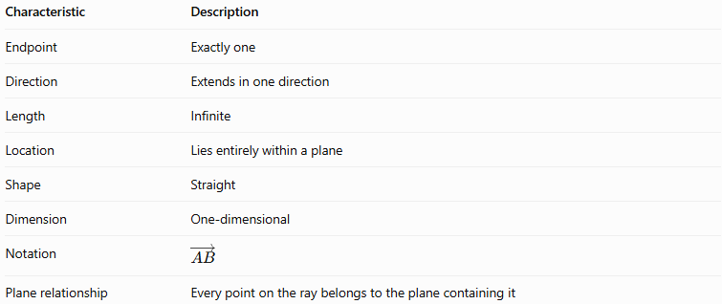
Characteristic | Description
Endpoint | Exactly one
Direction | Extends in one direction
Length | Infinite
Location | Lies entirely within a plane
Shape | Straight
Dimension | One-dimensional
Notation | $$\overset{→}{AB}$$
Plane relationship | Every point on the ray belongs to the plane containing it
A ray in a plane is still a one-dimensional geometric object. The plane containing it is two-dimensional.

Types and examples of rays in a plane

A. Ray in a coordinate plane
# Source: AI Source: Provided by: [Data Path: Persons Table -> ID Column: 1, Name_En Column: Motasem Essam] -> From: [ChatGPT] on [7/25/2026]
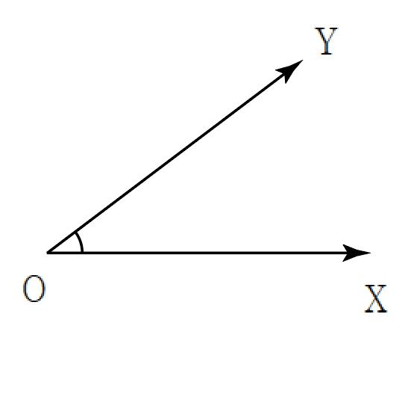
A ray can lie within one of the coordinate planes, such as the $xy$-plane.
Every point on the $xy$-plane has $z=0$.
For example:
$$\left(x,y,z\right)=\left(t,2t,0\right), t≥0$$
This ray begins at the origin and extends in the direction $\left(1,2,0\right)$.

B. Ray within an arbitrary plane
# Source: AI Source: Provided by: [Data Path: Persons Table -> ID Column: 1, Name_En Column: Motasem Essam] -> From: [ChatGPT] on [7/25/2026]
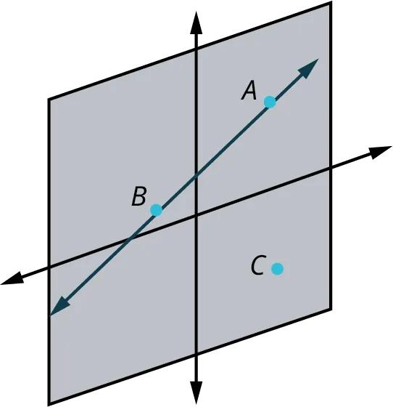
A ray can lie in a plane that is tilted relative to the coordinate axes.
Its endpoint and direction determine the ray, while the plane determines the flat surface containing it.
The ray remains in the plane even when it is not parallel to any coordinate axis.

C. Ray along a line on a solid's face
# Source: AI Source: Provided by: [Data Path: Persons Table -> ID Column: 1, Name_En Column: Motasem Essam] -> From: [ChatGPT] on [7/25/2026]
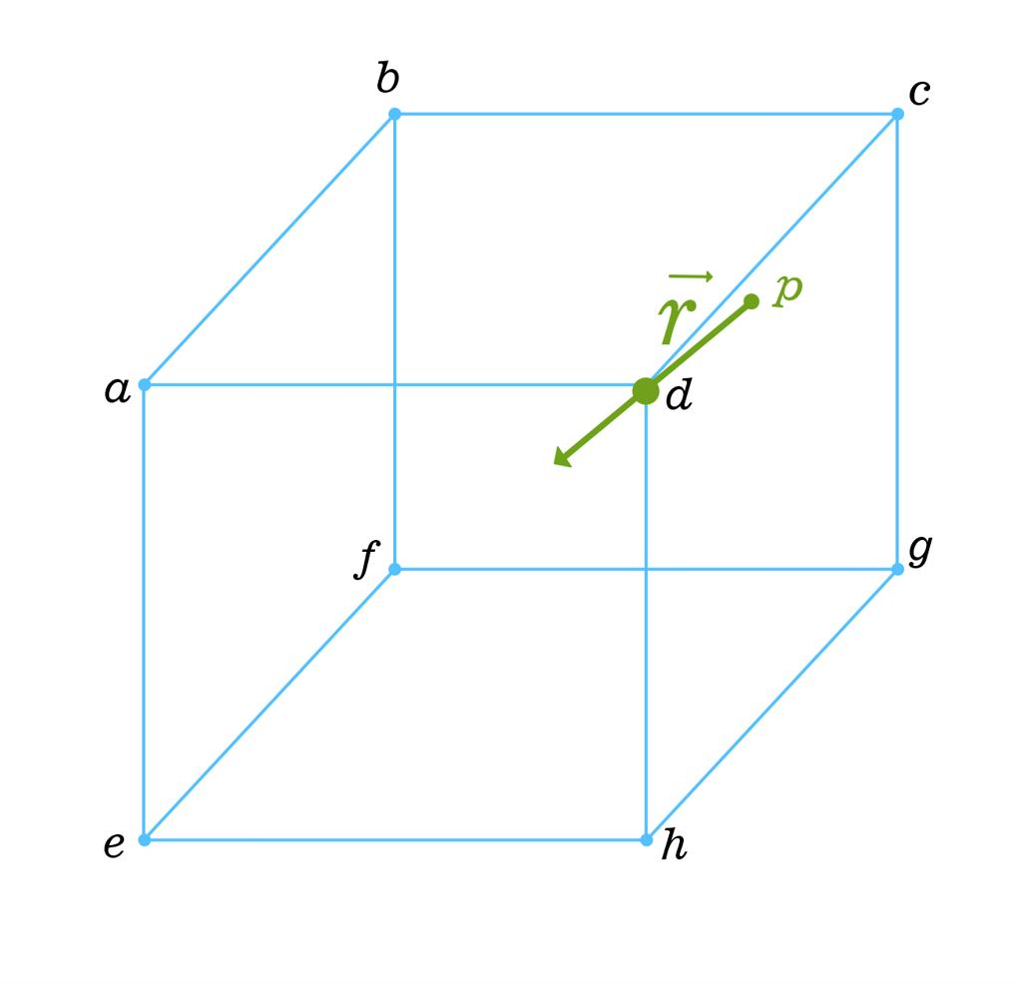
A ray may lie in the plane containing one of a solid's faces.
For example, a ray can start at a point on a square face of a cube and continue across the face's plane.
Important: If the ray extends beyond the boundaries of the square face, it remains in the face's plane but no longer lies entirely on the finite face itself.

D. Ray parallel to a plane
# Source: AI Source: Provided by: [Data Path: Persons Table -> ID Column: 1, Name_En Column: Motasem Essam] -> From: [ChatGPT] on [7/25/2026]
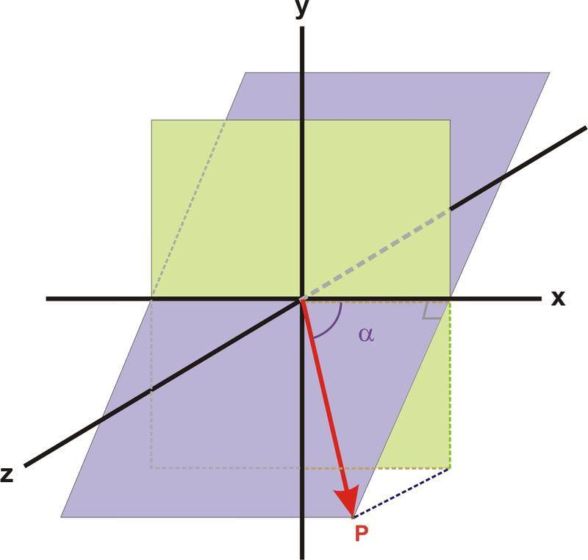
A ray can also lie in one plane that is parallel to another plane.
For example, a ray in the plane $z=3$ is parallel to the $xy$-plane, where $z=0$, provided its direction is parallel to the $xy$-plane.
This is a relationship between two planes, rather than a special type of ray.

Mathematical representations

A. General equation of a plane
# Source: AI Source: Provided by: [Data Path: Persons Table -> ID Column: 1, Name_En Column: Motasem Essam] -> From: [ChatGPT] on [7/25/2026]
A plane in three-dimensional space can be written as:
$$\boxed{ax+by+cz+d=0}$$
where $a,b,c$ are not all zero.
For a ray to lie entirely in this plane, its endpoint must lie on the plane and its direction must be parallel to the plane.

B. Vector equation of a ray in a plane
# Source: AI Source: Provided by: [Data Path: Persons Table -> ID Column: 1, Name_En Column: Motasem Essam] -> From: [ChatGPT] on [7/25/2026]
Let the endpoint be $A=\left(x_{0},y_{0},z_{0}\right)$, and let the direction vector be $v=\left(u,v,w\right)$.
The ray is represented by:
$$\boxed{r\left(t\right)=A+tv, t≥0}$$
To ensure the ray lies in the plane $ax+by+cz+d=0$, two conditions must hold.
Condition 1: The endpoint lies on the plane.
$$\boxed{ax_{0}+by_{0}+cz_{0}+d=0}$$
Condition 2: The direction vector is parallel to the plane.
$$\boxed{au+bv+cw=0}$$
The second condition states that the direction vector is perpendicular to the plane's normal vector $\left(a,b,c\right)$.

C. Parametric equations
# Source: AI Source: Provided by: [Data Path: Persons Table -> ID Column: 1, Name_En Column: Motasem Essam] -> From: [ChatGPT] on [7/25/2026]
The ray's coordinate equations are:
$$\boxed{\begin{aligned}x&=x_{0}+ut \\ y&=y_{0}+vt \\ z&=z_{0}+wt\end{aligned} t≥0}$$
When $t=0$, the point is the endpoint. As $t$ increases, the ray extends in its chosen direction.

D. Ray in the \(xy\)-plane
# Source: AI Source: Provided by: [Data Path: Persons Table -> ID Column: 1, Name_En Column: Motasem Essam] -> From: [ChatGPT] on [7/25/2026]
The $xy$-plane has equation $z=0$.
A ray beginning at $\left(x_{0},y_{0},0\right)$ with direction $\left(u,v,0\right)$ is:
$$\boxed{\left(x,y,z\right)=\left(x_{0}+ut, y_{0}+vt, 0\right), t≥0}$$
At least one of $u$ and $v$ must be nonzero so the direction vector is not zero.

Worked examples
# Source: AI Source: Provided by: [Data Path: Persons Table -> ID Column: 1, Name_En Column: Motasem Essam] -> From: [ChatGPT] on [7/25/2026]
Example 1: Determine whether a ray lies in a plane
Consider the plane:
$$x+y+z=6$$
and the ray:
$$r\left(t\right)=\left(1,2,3\right)+t\left(1,-1,0\right), t≥0$$
Step 1: Check the endpoint.
$$1+2+3=6$$
The endpoint lies on the plane.
Step 2: Check the direction vector.
The plane's normal vector is $\left(1,1,1\right)$, and the ray's direction vector is $\left(1,-1,0\right)$.
$$\left(1,1,1\right)⋅\left(1,-1,0\right)=1-1+0=0$$
The direction vector is parallel to the plane.
Answer: The entire ray lies in the plane $x+y+z=6$.
Example 2: Write a ray in the \(xy\)-plane
A ray begins at $A=\left(2,3,0\right)$ and points in the direction $\left(4,1,0\right)$. Write its equation.
Step 1: Use the vector equation.
$$r\left(t\right)=A+tv$$
Step 2: Substitute the endpoint and direction.
$$\boxed{r\left(t\right)=\left(2,3,0\right)+t\left(4,1,0\right), t≥0}$$
Step 3: Write the parametric form.
$$\boxed{x=2+4t, y=3+t, z=0, t≥0}$$
Since $z=0$ for every value of $t$, the ray remains in the $xy$-plane.
Example 3: Find a point on a ray in a plane
A ray is given by:
$$r\left(t\right)=\left(1,2,0\right)+t\left(2,3,0\right), t≥0$$
Find the point corresponding to $t=3$.
Step 1: Substitute $t=3$.
$$x=1+2\left(3\right)=7$$
$$y=2+3\left(3\right)=11$$
$$z=0$$
Answer:
$$\boxed{P=\left(7,11,0\right)}$$
The point belongs to the ray and lies in the $xy$-plane.
Example 4: Determine whether a ray lies in the \(xy\)-plane
Consider:
$$r\left(t\right)=\left(2,1,0\right)+t\left(3,4,1\right), t≥0$$
The endpoint lies in the $xy$-plane because its $z$-coordinate is zero.
However, the direction vector has a nonzero $z$-component. Therefore:
$$z=t$$
For $t>0$, the ray leaves the $xy$-plane.
Answer: The ray does not lie entirely in the $xy$-plane.

Comparison with related concepts
# Source: AI Source: Provided by: [Data Path: Persons Table -> ID Column: 1, Name_En Column: Motasem Essam] -> From: [ChatGPT] on [7/25/2026]
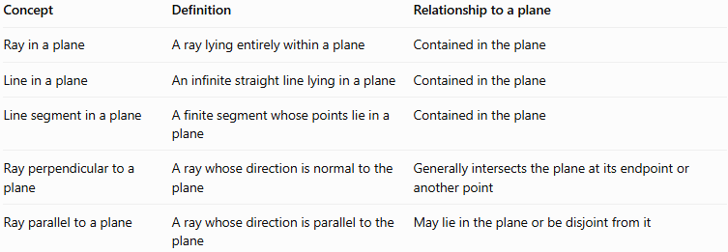
Concept | Definition | Relationship to a plane
Ray in a plane | A ray lying entirely within a plane | Contained in the plane
Line in a plane | An infinite straight line lying in a plane | Contained in the plane
Line segment in a plane | A finite segment whose points lie in a plane | Contained in the plane
Ray perpendicular to a plane | A ray whose direction is normal to the plane | Generally intersects the plane at its endpoint or another point
Ray parallel to a plane | A ray whose direction is parallel to the plane | May lie in the plane or be disjoint from it
Key distinction: A ray parallel to a plane does not necessarily lie in that plane. Its endpoint must also belong to the plane for the entire ray to be contained in it.

Practical applications
# Source: AI Source: Provided by: [Data Path: Persons Table -> ID Column: 1, Name_En Column: Motasem Essam] -> From: [ChatGPT] on [7/25/2026]
- Technical drawing: representing straight paths within flat surfaces.
- Computer graphics: modeling directional paths across a planar surface.
- Optics: representing light traveling across a flat mirror or other planar surface.
- Architecture: describing directions along floors, walls, and other planar surfaces.
- Coordinate geometry: testing whether a ray is contained in a specified plane.

Key points
# Source: AI Source: Provided by: [Data Path: Persons Table -> ID Column: 1, Name_En Column: Motasem Essam] -> From: [ChatGPT] on [7/25/2026]
- A ray in a plane has one endpoint and extends infinitely in one direction.
- Every point of the ray lies in the same plane.
- The ray is one-dimensional, while the plane is two-dimensional.
- Its vector equation is $r\left(t\right)=A+tv$, with $t≥0$.
- The endpoint must satisfy the plane equation.
- The direction vector must be perpendicular to the plane's normal vector.
- A ray may lie in a coordinate plane or in an arbitrarily oriented plane.

Conclusion
# Source: AI Source: Provided by: [Data Path: Persons Table -> ID Column: 1, Name_En Column: Motasem Essam] -> From: [ChatGPT] on [7/25/2026]
A ray in a plane combines the one-directional, infinite nature of a ray with the flat geometry of a plane. In solid geometry, vector equations and plane equations provide a precise way to determine whether a ray lies entirely within a plane.

